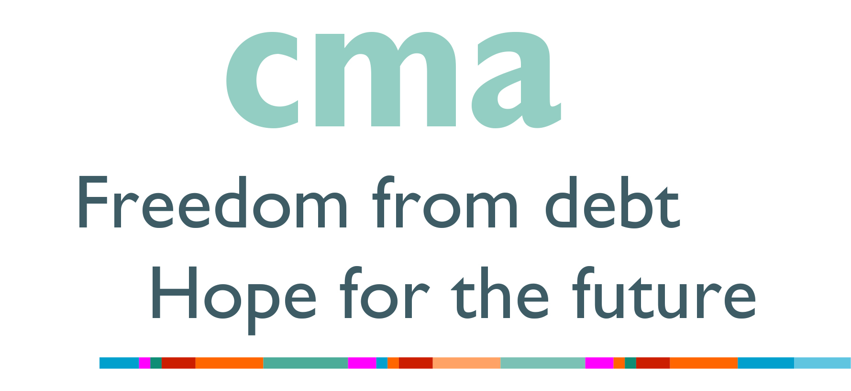

This booking form is for those wishing to host a F2F training day. If you do not wish to host a training day but have individuals who require training, please go to our website at:
https://www.communitymoneyadvice.com/training-and-events-shop where you will be able to book onto available dates online.

CMA Training Booking Guide

Thank you for requesting your training day(s) with Community Money Advice. We would like to ensure that the delegates who book onto our training obtain the maximum possible benefit from the training day and we are keen to ensure that the booking process and the day itself go as smoothly as possible.

You will find the Venue Booking Form below this guide. Please complete this in full as soon as possible and return by email to: training@communitymoneyadvice.com. Once we have received your booking form, we will be in touch with you to confirm your request or we will contact you as necessary, to discuss your requirements.

We have a team of CMA trainers who may choose to present the course material using different methods and training aids. As a general rule our trainers will normally use a laptop, data projector and screen (or suitable area for projecting onto) and some may use a flip chart, stand and pens. Please complete all these sections on the form so we know what will be available on the day.

CMA face-to-face training days will have up to a maximum of 20 delegates. Please complete the relevant section on the booking form as to what the maximum comfortable seating capacity will be in your training room, with chairs and tables in a horseshoe shape.

If you find that you need to use a venue that requires a charge and you wish CMA to contribute, then this must be discussed with us as soon as possible and in any event, before the training day.

CMA would be grateful if you could arrange for refreshments to be provided on arrival and for a mid-morning and mid-afternoon break. Lunch is usually provided by the delegates themselves, but if there is some alternative arrangement being planned, please indicate on the form.

The training itself will usually run from 10.00am until 4.00pm with prior access to the training room required, in order to allow plenty of time to check set up and equipment before the training starts. If the location of the training room within the building is not immediately apparent, please ensure that people are around to give directions or that signage is provided.

If problems are encountered at any time during the booking process leading up to the event, please email: training@communitymoneyadvice.com. If there are any issues that need to be discussed regarding any situations on the actual training day, please contact the trainer whose details you will receive.

Thank you for booking this event and CMA trusts that you and your delegates will have an enjoyable and fulfilling training event.

CMA Training Booking Cancellation Policy

It is expected that all bookings to attend CMA training days, will be honoured by both CMA as the training provider and the booked delegate as the customer.

All requests to cancel/amend a booking must be emailed to: training@communitymoneyadvice.com

If the email request for cancellation or amendment is received more than 14 days before the booked training date, we will contact you to agree one of the following:
- the booked delegate attending an alternative available training date.
- holding a credit for a future booking.
- arranging a refund if requested.
If not immediately agreeing an alternative date, any hard copy materials previously supplied for the booked training, must be returned to CMA Head Office.

If the email request for cancellation or amendment is received within 14 days of the booked training date, we will contact you to discuss the circumstances surrounding the request. Any changes we agree to, as regards arranging an alternative date(s), holding a credit or arranging a refund, will be subject to our discussions with you and may take into account the following factors:
- whether the request is due to an emergency situation.
- how soon before the booked training date the request is received.
- whether the training course remains viable, based on the remaining numbers of delegates.
If not immediately agreeing an alternative date, any hard copy materials previously supplied for the booked training must be returned to CMA Head Office.

If a delegate does not attend a booked training day within 30 minutes of the planned start time and no prior notice is received by CMA Training, the course fee will be forfeited in full and any future attendance will need to be re-booked at the appropriate cost - excepting unavoidable emergency situations.

Hard copy materials previously supplied, will need to be returned to CMA Head Office before any refunds are made. Any unreturned training manuals (or damaged returns) will be charged at £10 each, which will be deducted from any refunds made or credits held. CMA will not pay for any return postage costs.

If CMA is required to cancel a training day, we will attempt to accommodate booked delegates on suitable alternative dates, agree to hold a credit for future training bookings or offer a full unconditional refund and pay the return postage costs for any previously supplied hard copy training materials.

Any questions regarding this policy should be emailed to: training@communitymoneyadvice.com

Community Money Advice
Venue Booking Form

PLEASE COMPLETE THIS FORM AND EMAIL TO OUR TRAINING DEPARTMENT: training@communitymoneyadvice.com

BOOKING INFORMATION
Title of training day required:
(eg: CMA Generalist Training Part 1)
Please supply four potential dates for your training day: | DAY | DATE
CMA Centre name / Other organisation
Postal address
Postcode
Booking contact – name
Booking contact – landline number
Booking contact – mobile number
Booking contact – email address
I confirm I have read both the Training Booking Guide and Cancellation/Refund Policy (above)
Address and postcode of venue
(if different to that above)

ACTUAL DAY OF THE EVENT
Contact person - on the day
Contact person - mobile number
Please confirm this mobile number will stay on until everyone has arrived
Timing of the training day (all courses run 10am to 4pm unless exceptional circumstances)
Is the training room accessible
45 minutes before the start time?
Is there disability access to the building and to the training room?
If the answer to the above question is “NO” please contact us to discuss as the training provider (CMA) is required to attempt reasonable adjustment should it be necessary
Extra instructions for getting to the training room (eg – ring bell, turn left etc)
Availability of heating if a cold day Y/N
Chairs & tables (horseshoe shape) Y/N
Comfortable room capacity (how many)
Is a projector available?
Is a screen/wall available?
Are flipchart & pens available?

PARKING
Parking spaces available at venue Y/N
Alternative parking elsewhere
Cost of parking
Distance to venue or at the venue

REFRESHMENTS / LUNCH
Are you okay to provide refreshments (tea/coffee/water)?
Delegates usually bring own lunch but any alternative arrangements planned?
Can lunch be purchased at the venue? Y/N
Can lunch be purchased locally? Y/N

DELEGATE BOOKING
How many delegates to you expect from your centre/organisation?
CMA will advertise this training day on the CMA website.
Please indicate here if this is a problem
Once this training event has been confirmed please ensure that you book your delegates onto the training using the CMA website booking page as soon as possible so that we know how many places might be available for outside bookings.
If you are unable to use the online booking (eg: you need an invoice) then we must have the names and email addresses of your delegates now so that we can confirm the training day will go ahead. Email addresses must be individual and cannot be used for more than one person for joining instructions and the post-course assessment.
DELEGATE NAME TO APPEAR ON THE CERTIFICATE |  | INDIVIDUAL EMAIL ADDRESS
IN THE UNLIKELY EVENT THAT THERE AREN’T ENOUGH BOOKINGS TO RUN THE TRAINING DAY WE WILL NOTIFY YOU 7 DAYS IN ADVANCE AND DISCUSS ALTERNATIVE ARRANGEMENTS OR DATES

MORE THAN ONE TRAINING DAY
If you are planning to host more than training day (eg: this form is for a Part 1 and you intend to host a Part 2 training day as well), please confirm here that all the arrangements in this document will be the same for any other training days.
If not please complete a separate form and email that to: training@communitymoneyadvice.com

OFFICE USE ONLY
Trainer
Dates agreed for training
Head Office notified
Notes

